Name-Ashutosh Uid-22BCS15124

Section-607/B

AP ASSIGNMENT

1. Longest Nice substring :

class Solution { public:

string longestNiceSubstring(string s) { int n = s.length();

string ans=""; for(int i=0;i<n;i++) {

int lower = 0 , upper = 0; for(int j=i;j<n;j++) {

if(s[j]>='a' && s[j]<='z')

lower |= (1<< (s[j]-'a')); else

upper |= (1<< (s[j]-'A')); if(!(lower^upper)) {

if(j-i+1>ans.size())

ans = s.substr(i,j-i+1);

}

}

}

return ans;

}

};

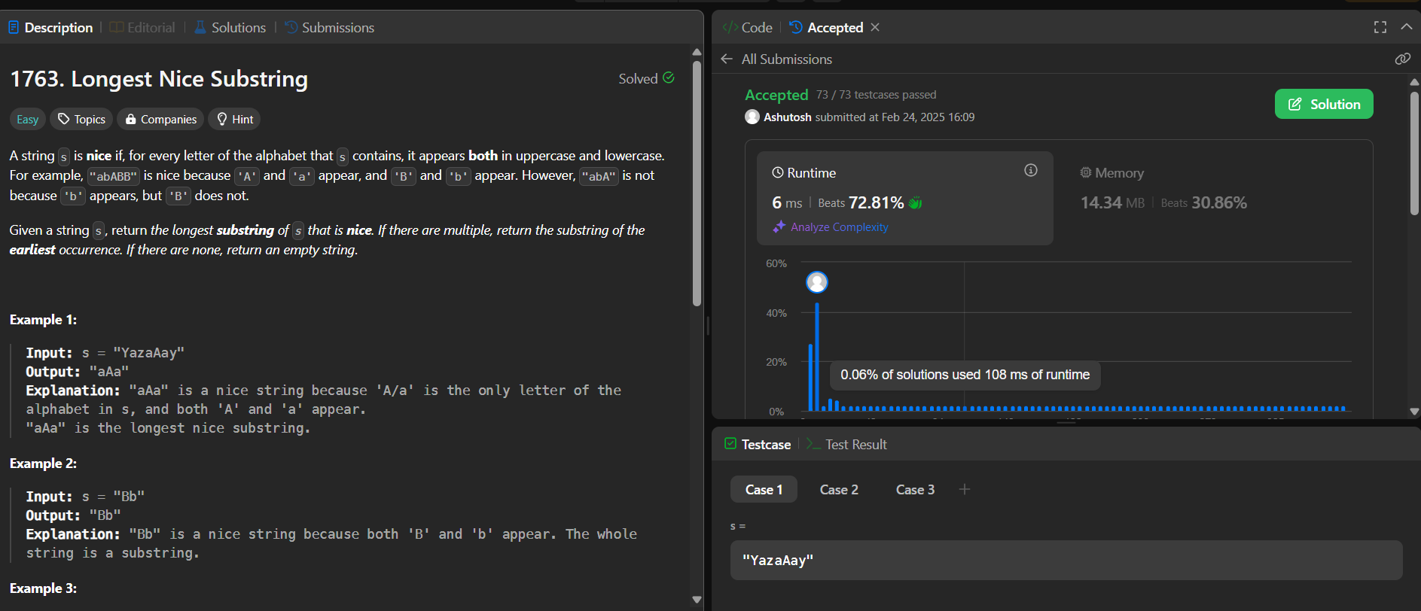

1. Reverse bits :

class Solution { public:

uint32_t reverseBits(uint32_t n) { uint32_t ans=0;

for (int i = 0; i < 32; i++) { ans = ans<<1; if(n&1){

ans=ans|1;

}

n = n>>1;

}

return ans;

}

};

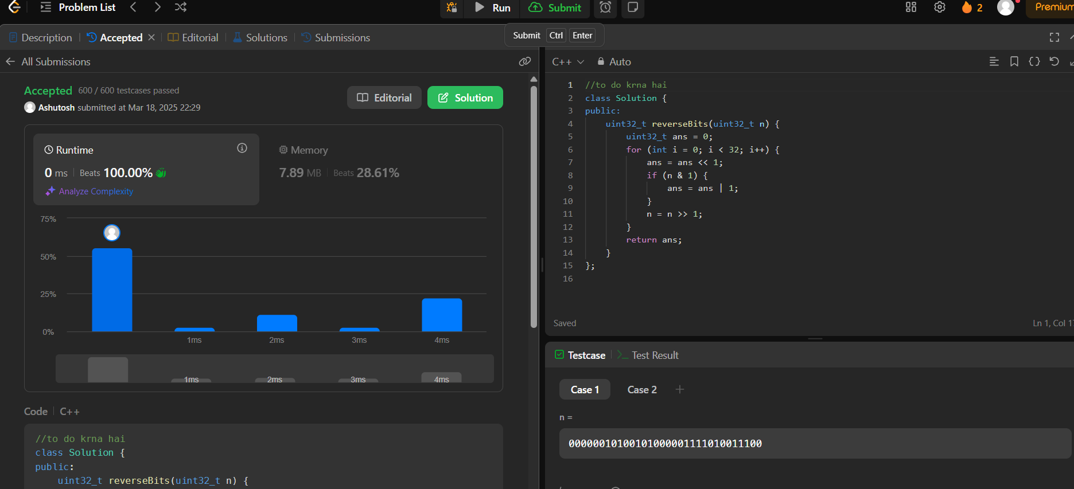

1. Number of 1-bits:

class Solution {

public:

int hammingWeight(uint32_t n) {

int count=0;

while(n!=0){

if(n&1){

count++;

}

n=n>>1;

}

return count;

}

};



1. maximum of subbarray:

class Solution { public:

int maxSubArray(vector<int>& nums) { int res = nums[0];

int total = 0;

for (int n : nums) { if (total < 0) { total = 0;

}

total += n;

res = max(res, total);

}

return res;

}

};

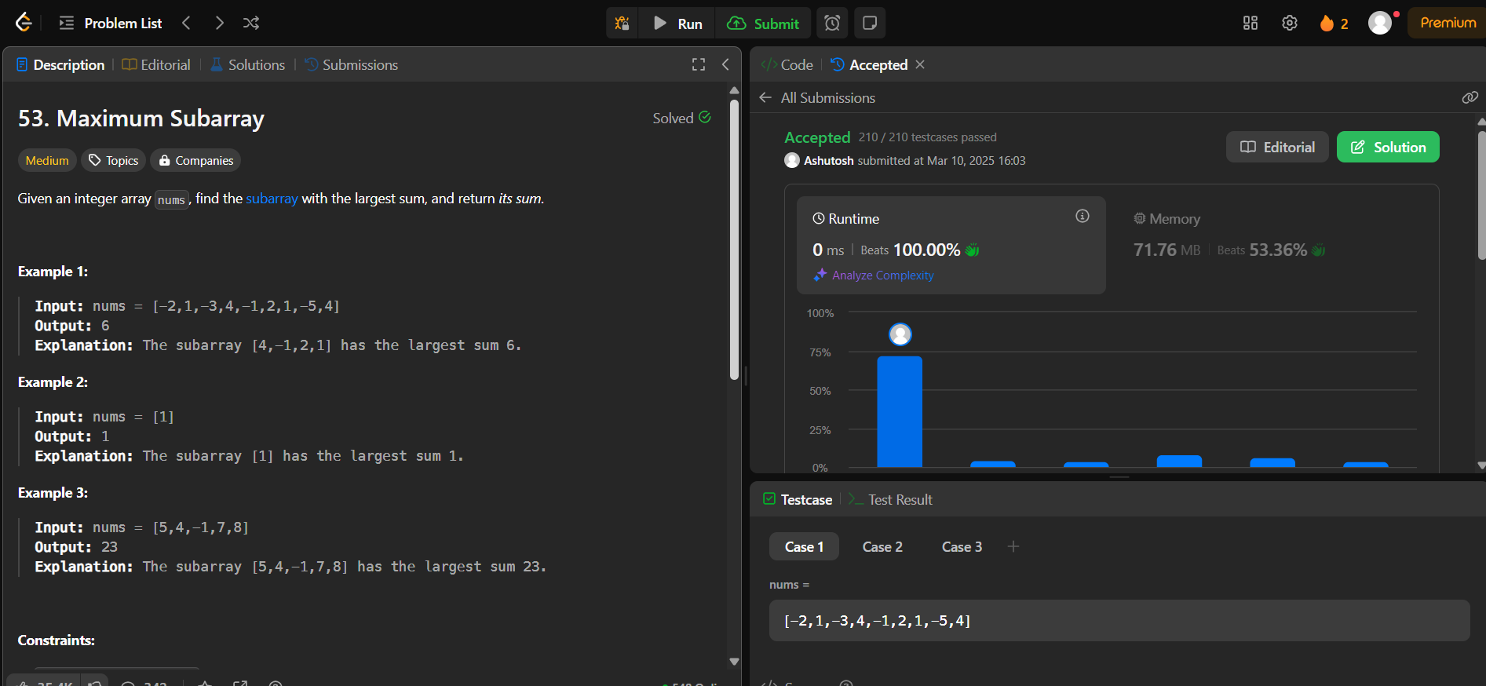

1. Search a 2D matrix :

class Solution { public:

bool searchMatrix(vector<vector<int>>& matrix, int target) { for (int i = 0; i < matrix.size(); i++) {

for (int j = 0; j < matrix[i].size(); j++) { if (matrix[i][j] == target) {

return true;

}

}

}

return false;

}

};

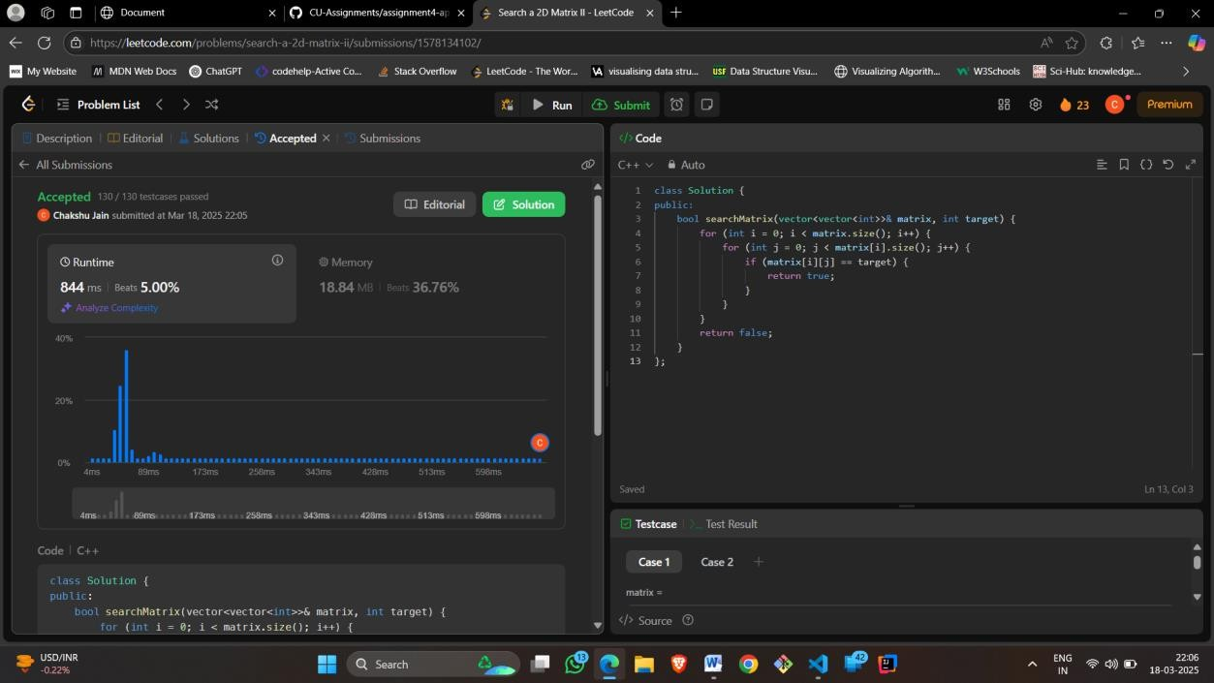

1. super pow:

class Solution {

const int base = 1337;

int powmod(int a, int k) //a^k mod 1337 where 0 <= k <= 10

{

a %= base; int result = 1;

for (int i = 0; i < k; ++i)

result = (result * a) % base; return result;

}

public:

int superPow(int a, vector<int>& b) { if (b.empty()) return 1;

int last_digit = b.back(); b.pop_back();

return powmod(superPow(a, b), 10) * powmod(a, last_digit) % base;

}

};

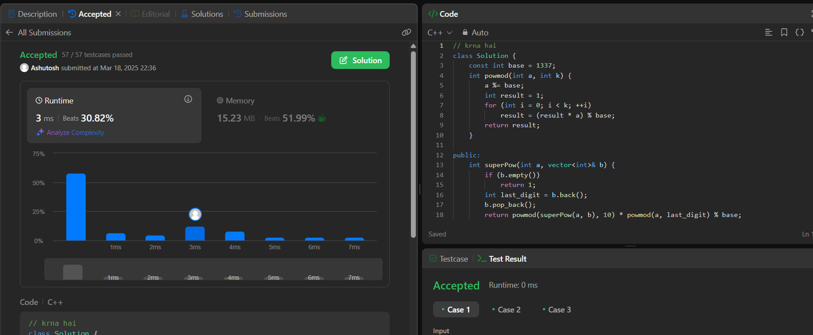

1. beautiful array :

class Solution { public:

int partition(vector<int> &v, int start, int end, int mask)

{

int j = start;

for(int i = start; i <= end; i++)

{

if((v[i] & mask) != 0)

{

swap(v[i], v[j]); j++;

}

}

return j;

}

void sort(vector<int> & v, int start, int end, int mask)

{

if(start >= end) return;

int mid = partition(v, start, end, mask); sort(v, start, mid - 1, mask << 1); sort(v, mid, end, mask << 1);

}

vector<int> beautifulArray(int N) { vector<int> ans;

for(int i = 0; i < N; i++) ans.push_back(i + 1); sort(ans, 0, N - 1, 1);

return ans;

}

};

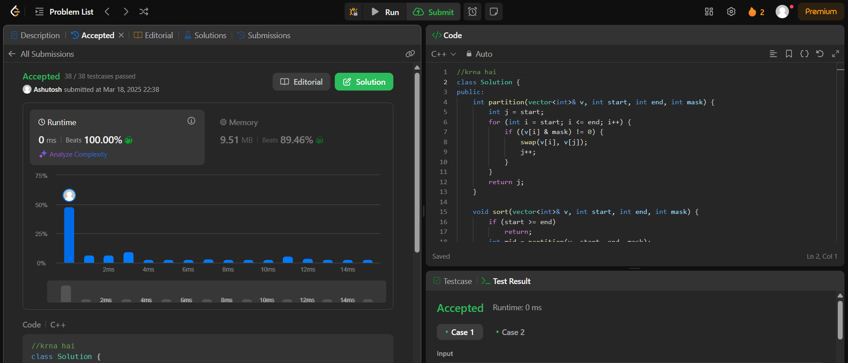

1. the skyline problem:

class Solution { public:

vector<vector<int>> getSkyline(vector<vector<int>>& buildings) { vector<vector<int>> ans;

multiset<int> pq{0};

vector<pair<int, int>> points;

for(auto b: buildings){ points.push_back({b[0], -b[2]});

points.push_back({b[1], b[2]});

}

sort(points.begin(), points.end());

int ongoingHeight = 0;

// points.first = x coordinate, points.second = height for(int i = 0; i < points.size(); i++){

int currentPoint = points[i].first;

int heightAtCurrentPoint = points[i].second;

if(heightAtCurrentPoint < 0){ pq.insert(-heightAtCurrentPoint);

} else {

pq.erase(pq.find(heightAtCurrentPoint));

}

// after inserting/removing heightAtI, if there's a change auto pqTop = *pq.rbegin();

if(ongoingHeight != pqTop){ ongoingHeight = pqTop;

ans.push_back({currentPoint, ongoingHeight});

}

}

return ans;

}

};

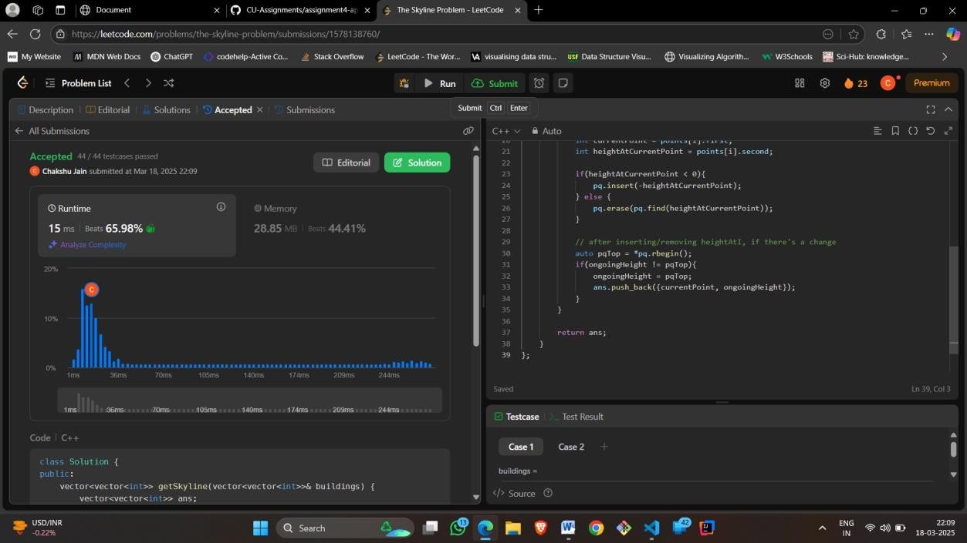

1. Reverse pairs :

class Solution

{

int get_pairs(vector<int>& vct , long long int x)

{

//sort(vct.begin() , vct.end()); int size = vct.size();

int low = 0;

int high = size - 1; int ans = -1; while(low <= high)

{

int mid = high - (high - low) / 2; int ele = vct[mid];

if(ele > x)

{

ans = mid; high = mid - 1;

}

else

{

low = mid + 1;

}

}

if(ans == -1) return 0; return vct.size() - ans;

}

// void print_vector(vector<int>& nums)

// {

// cout<<endl;

// for(auto it : nums)

// {

// cout<<" "<<it;

// }

// cout<<endl;

// }

public:

int reversePairs(vector<int>& nums)

{

vector<int> vct; int counter = 0; for(auto it : nums)

{

long long int x = 1LL * 2 * it; counter += get_pairs(vct , x); int low = 0;

int high = vct.size(); int ans = vct.size(); while(low < high)

{

int mid = low + (high - low) / 2; if(vct[mid] >= it)

{

ans = mid; high = mid;

}

else

{

low = mid + 1;

}

}

vct.insert(vct.begin() + ans , it);

//print_vector(vct);

}

return counter;

}

};

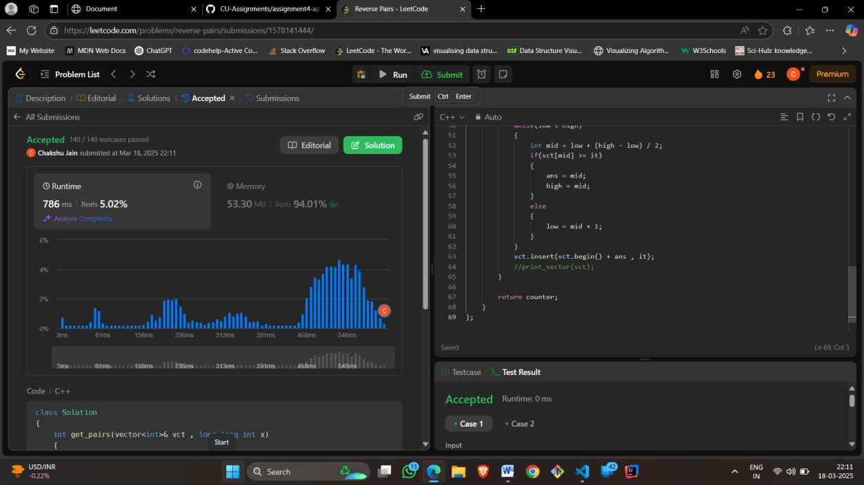

1. longest increasing substring : class Solution {

public:

vector<int>tree;

void update(int node,int st,int end,int i,int val){ if(st==end){

tree[node]=max(tree[node],val); return;

}

int mid=(st+end)/2; if(i<=mid){

update(node*2,st,mid,i,val);

}else{

update(node*2+1,mid+1,end,i,val);

}

tree[node]=max(tree[node*2],tree[node*2+1]);

}

int query(int node,int st,int end,int x,int y){ if(x>end || y<st) return -1e9;

if(st>=x && end<=y){ return tree[node];

}

int mid=(st+end)/2;

int left=query(2*node,st,mid,x,y);

int right=query(2*node+1,mid+1,end,x,y); return max(left,right);

}

int lengthOfLIS(vector<int>& nums, int k) { int n=nums.size();

if(n==1) return 1;

int m=*max_element(nums.begin(),nums.end());

tree.clear(); tree.resize(4*m+10); for(int i=n-1;i>=0;i--){

int l=nums[i]+1,r=min(nums[i]+k,m); int x=query(1,0,m,l,r);

if(x==-1e9) x=0; update(1,0,m,nums[i],x+1);

}

return tree[1];

}

};

